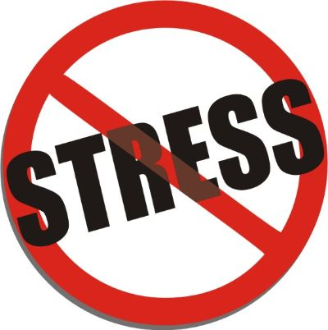
What stresses you out?
Below, list some of the things which cause you to get stressed e.g. not being able to get time alone, school work, too much noise when you’re trying to complete school work, having to care for younger siblings…
1.
2.
3.
4.
5.
6.
7.
8.
9.
10.
Now think about how you react when you are stressed… do you slam doors, shout, go quiet, cry, get hot, tense up, ball your hands or toes, get easily irritated? Do you focus only on what is stressing you out or does your mind block it out?
Body | Mind | Emotions | Behaviours
Circle of control
Now think again about the list you made of things which stress you out, think about which of those things you can control and which are out of your control and write them in the circles below.
Everything else

In my control
What can I control, influence or change?

The key is to focus on the things you can control
Out of my control

Unfortunately, we can’t change the things which are out of our control so the key is to focus on what is in your control. Think about how you can make small changes with these things to cause you less stress.
Stress bucket and coping strategies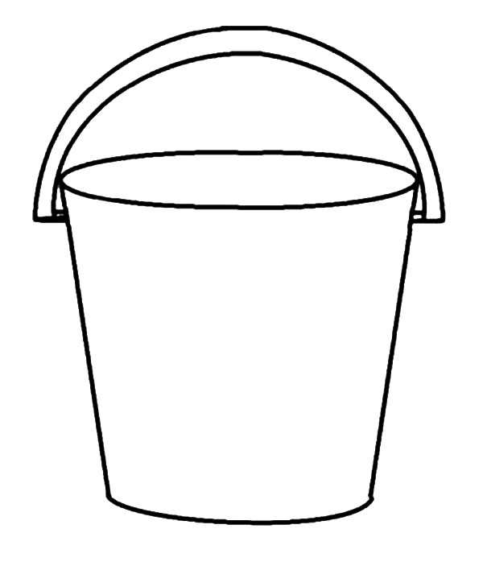
Imagine all of your stresses were to flow in to a bucket, eventually that bucket would overflow. Now imagine that bucket was you. When you are full of stress, rather than overflowing it would all become too much for you and you might ‘snap’.

To help prevent you from overflowing you need to find a helpful release or coping strategy. This might look very different from person to person but the important thing is that it doesn’t cause anyone, including yourself, any further stress or harm.
Common coping strategies include talking to someone, going for a walk, exercise (including dancing while no one is watching!), colouring, meditation or breathing exercises. It’s important you find what works for you!
My favourite coping strategies:
Other strategies I could try:

Places to get support if it gets too much:

Parent / carer / family member

Teacher
GP

Youth Enquiry Service (YES)
Youth Worker

Friend

Youth Enquiry Project (YES) - free phone 0800 735 0010, by text on 07797778424 or via email yes@jys.je

