Goal setting

Setting goals can be a scary idea but when tackled correctly, they can force you out of your comfort zone and help you grow more than you would without them. And, perhaps most importantly, they give us control of our destiny. Just by setting a goal, you are taking an active role in driving new and better results in your life. What could be more important than that?

It’s recommended that goals are SMART:
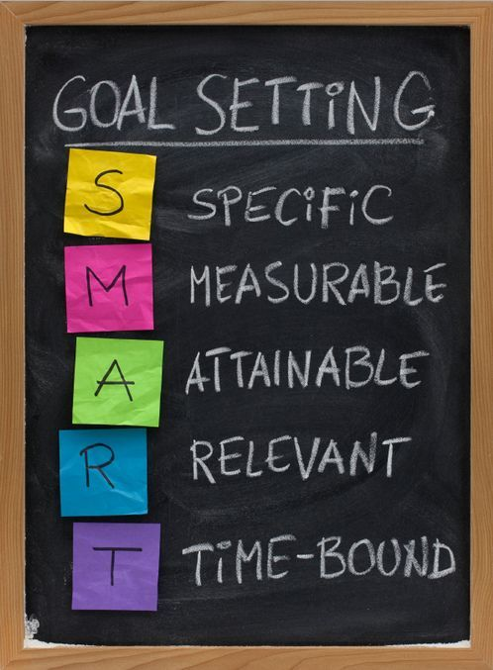
Specific – you should be clear on what you want to achieve
Measurable – you need to know when you have achieved the goal
Attainable – or achievable, something you can work towards achieving - winning £1million is not a goal, you can’t work towards achieving it!
Relevant – it needs to be something that means something to you
Time-bonded – you set a time in which to achieve that goal, e.g. you might want to learn how to cook a particular thing this weekend, study certain subjects for GCSE/A-Level or travel the world.

When setting goals, it’s important to thing about where you want to go and how you can get there. Think about life goals, educational/work goals and social goals but remember that it’s ok not to have a goal in all areas of your life all the time!
Take some time to think about any goals you have and write them down below.

Short Term Goals (in the next few days or weeks) | Medium Term Goals (in the next few months/year) | Long Term Goals (beyond a years time)

Now you have written down your goals, think about how you might achieve them. Start off with one or two which mean the most to you and which you feel confident you can work towards. How are you going to get there? It is often easy to get overwhelmed and think a goal is unachievable when really it isn’t at all, just take some time to think about how you can break down the goal in to smaller steps.

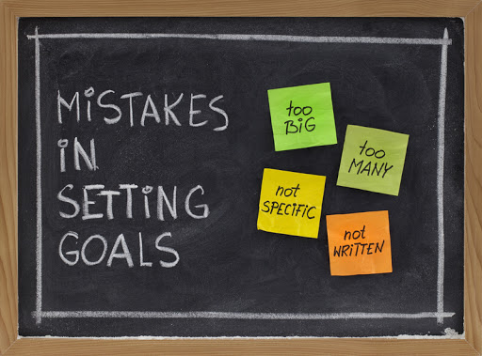

Write down your plan below.

What is your goal? | How will you know you have achieved it? | When do you hope you will have achieved it? | What is your plan for reaching this goal?

Sometimes we need help to achieve our goals, there might be people who are in a good place to help you! Family, teachers, youth workers, coaches… don’t be afraid to ask for their help.

Now go out and start achieving those goals!

